**Info pack Training course IQ ESC:**

**A Training course about “Inclusion and Quality in ESC”**

**Project number:** **2019-2-NL02-KA105-002583**

**by Filaretos Vourkos and Chris van Maanen, co-trainer Raluca Oancea.**

**dates: arrival 11 of November 2019 - departure 21 of November 2019**

* It is a Training so of course it is mandatory that the participants speak English. Please share this also with your participants.
* We can discuss the program with you, so we can adapt it as good as possible to the group, in the excel you find the general idea
* You can start selecting your participants and looking for tickets, ☺ budget according to Erasmus rules, anyway, check with me before buying ☺

The final participants will be as divided below:

* Netherlands Rock Solid: 4 persons: 2 trainers/facilitators – 2 participants
* Germany VIA: 2 persons
* Greece KANE: 3 persons – 1 trainer – 2 participants
* Romania ADAPTO: 5 persons – 1 trainer – 1 participant – 1 accompanying person + cooking staff
* Spain AJS: 2 person
* Slovenia ODTIZ: 3 persons – 2 participants – 1 accompanying persons
* Austria Akzente: 2 persons
* Hungary ODE: 2 persons
* Turkey Ebagem: 2 persons – 1 participant – 1 accompanying person
* Turkey CCYD: 2 persons
* Macedonia Youth Can: 2 persons

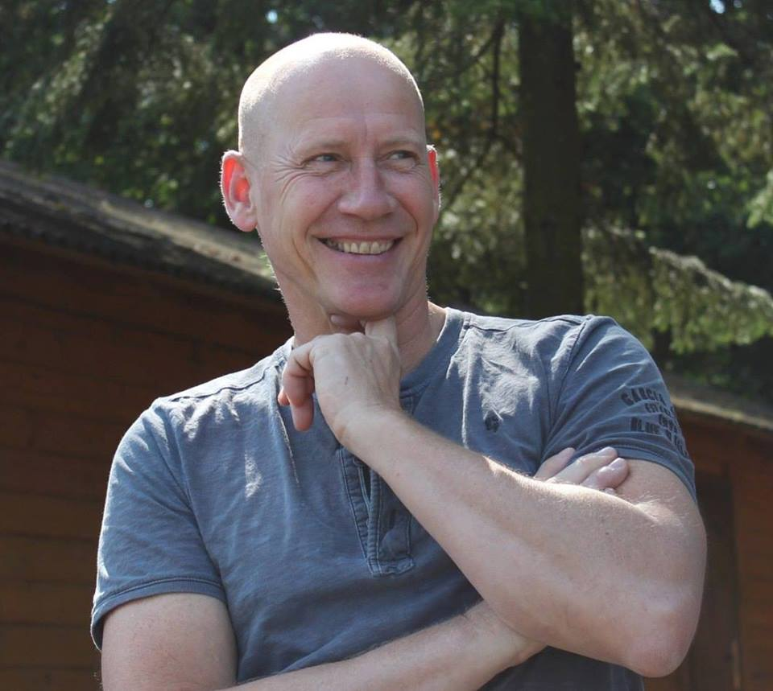Trainers: Chris van Maanen <https://www.facebook.com/chris.vanmaanen>

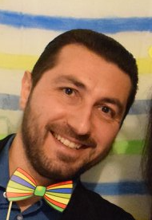& Filaretos Vourkos: <https://www.facebook.com/Filaretos>

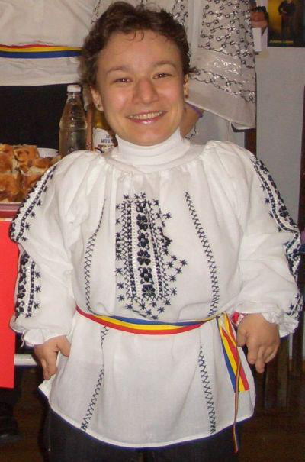& co-trainer: Raluca Oancea: <https://www.facebook.com/raluca.oancea.11>

Facebookgroup: Inclusion and Quality in ESC : <https://www.facebook.com/groups/902325073472696/>

Information about the Venue: (as it seems now, but there can be changes)

1 eight persons stone house (adapted) with if needed 2 extra matrasses

5 x fishermans cottage (6 beds)

After we have all the participants info we will make a devision of the houses.

Conference room “de Kapschuur” for the whole period

Adress: Schoterpad 1, 8314RA BANT, Netherlands. tel 0031527-261899 (there is wifi)

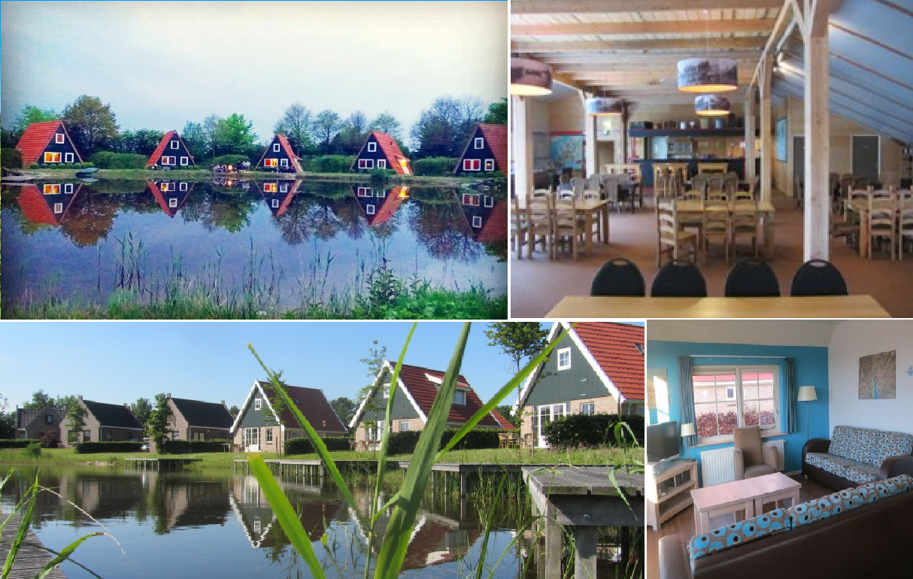

**What to prepare:**

* **There will be several intercultural evenings: in that evenings several countries will present their organisation and their country, but also will teach us something interactive, like a song or a dance or be creative! and a table with some drinks and food!**
* **Every country should prepare a small presentation about their organisation and their wishes for cooperation for the future and if there were any after effects from the PBA we had last year, and if yes which projects were set up?**
* **BRING YOUR OWN TOWELS! (BED SHEETS ARE PROVIDED)**
* **BRING SOME CLOTHES FOR CARNIVAL NIGHT!**
* **FOR THE EVENINGS WE WILL PROVIDE DRINKS FOR SUPERMARKET PRICES, SO YOU CAN PUT IT ON THE LIST AND IN THE END OF THE WEEK PAY WHAT YOU USED ☺**
* **BRING A SWIMSUIT IF YOU WANT TO ENJOY THE HOTTUB IN THE EVENINGS (or to swim in the lakes) ☺**

**TRAVEL FOR PEOPLE WHO WANT THE EASY WAY!**

* **We will arrange a bus from Schiphol (Amsterdam airport) to the venue to pick you up from the airport on 11 nov around 20.00**
* **We will arrange a bus from the venue to Schiphol (Amsterdam airport) to bring you back to the airport on 21 nov around 6.00**

**Then you need to book your tickets accordingly of course, if there are slight differences in time we will adapt the hours. (if you have many waiting hours then you can go (on your own expenses) to Amsterdam in your waiting time, it is 15 min by train directly from the airport)**

**The meeting point in the airport is in the arrival hall and is close to the burger king, now it is just a small billboard on a stick (not the cube anymore)**

**TRAVEL FOR PEOPLE WHO WANT IT THE HARD WAY ☺**

**You can fly on every available airport in the Netherlands, and from there travel by train. (Amsterdam is the most convenient, but Eindhoven will do also)**

**You can travel by train to Lelystad central station (from every airport) it will cost you 1-3 hours, from there you taken the bus to Emmeloord and from Emmeloord you take the bus to Bant, then it is about 5 km walking (if possible we will pick you up)**

**You can book the train tickets quit easy online on** [**www.ns.nl**](http://www.ns.nl) **, you can switch to English, you book 2nd class, no discount one way tickets, so one one-way ticket for coming and one for going ☺, in the Netherlands we don’t have fixed seats in the train and also you can use the train ticket all day long. So there is no fixed time. You can also go out and back in, so you can go from Schiphol to Amsterdam central and go a few hours to the city and then go back in the train and go to Lelystad. we calculate them of course for the travel costs. (from Eindhoven single trip is 21,50, from Amsterdam is 11,50, this is in your total costs for the travel.**

**As soon as you found tickets then let me know and i will help you with the rest ☺, at least try to be in time before the start and don’t leave before the end! We cannot stay longer then the program nights in the venue. You are allowed to come earlier or leave later if you want to spend some time in the Netherlands extra. Of course, then the hostel and food will be for your own costs.**

**Summary of the project:**

Our organization is dedicated in inclusion of young people with disabilities or fewer opportunities in volunteering activities. Being at the beginning of European Solidarity Corps, creates some uncertainty about the methods and good practices, which were working for EVS. We believe that, we and our partners, need to discuss and be trained at the new functions of the Program.

This Course will offer ideas, examples and practical technicals through which youth workers can engage with challenging questions and better understand the context the new Program is setting. What are the perspectives of young people with fewer opportunities currently? How to identify a young person at risk? What are the causes of low participation? What are the responses to it? How can a youth worker make a difference? What ar the new practicalities behind the ESC program?

Using already new and existing tools like the SALTO resources, debates and exchange of good practices, the aim is to train youth workers and give them tools to develop volunteering activities based on the quality and inclusion.

The objectives of this project are:

- To train youth workers and bring them tools to face the changes and the new challenges of ESC

- To support frontline practitioners, especially youth workers, with practical tools that already exist

- To reflect about identification methods and how to increase the quality for the young people

- To create an informal group of support among the participants to help each other and exchange after the end of the project

- To create a Booklet of best practices for the volunteering activities under the European Solidarity Corps Program.

This project tends to contribute to the achievement of the promotion of European values in accordance with Article 2 of the Treaty on the European Union, as noticed in the Erasmus+ guide. It is linked to the Key Action 1 because it supports mobility of youth workers to undertake a learning in another country.