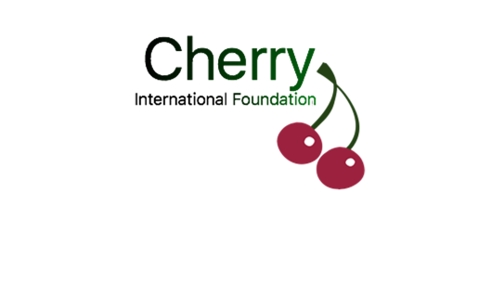
Back to Basics

Ommen, The Netherlands
25-26 April, 2019
6 – 20 August, 2019

Name and Surname as stated in passport
How would you like to be named in the exchange?
Home Address
Postal Code + Town
Date, Place and Country of Birth
What is your age on 06/08/2019?
Male / Female
E-mail Address
Link of your Facebook profile
(e.g. https://www.facebook.com/eddie.wolters.3)
Phone Number

What is the reason you want to participate in this exchange?
What expectations do you have?
What kind of work experience do you have?
If you are currently unemployed, for how long are you unemployed?
What kind of education do you have/are you in?
What kind of work would you like to do?
What do you know about entrepreneurship?
What is entrepreneurship for you?
What specific skill do you have which can be useful for the exchange?
Level of English (bad, medium, good, excellent)
Are you afraid of dogs?
Can you swim?
Do you know how to ride a bicycle?
Do you suffer from Nyctophobia (fear of the dark?)
Have you ever camped outdoor?
Do you have any special needs? Like medicins or dietary requirements (allergy, food allergy, vegetarian, etc.)
Contact person in case of emergencies (name and phone number)
Other remarks or questions?

Thank you for applying to be in the Back to Basics project

